Distribute Books
Solution will be Updated soon…
Distribute Books
Problem Description
For enhancing the book reading, school distributed story books to students as part of the Children’s day celebrations.
To increase the reading habit, the class teacher decided to exchange the books every weeks so that everyone will have a different book to read. She wants to know how many possible exchanges are possible.
If they have 4 books and students, the possible exchanges are 9. Bi is the book of i-th student and after the exchange he should get a different book, other than Bi.
B1 B2 B3 B4 – first state, before exchange of the books
B2 B1 B4 B3
B2 B3 B4 B1
B2 B4 B1 B3
B3 B1 B4 B2
B3 B4 B1 B2
B3 B4 B2 B1
B4 B1 B2 B3
B4 B3 B1 B2
B4 B3 B2 B1
Find the number of possible exchanges, if the books are exchanged so that every student will receive a different book.
Constraints
1<= N <= 1000000
Input Format
Input contains one line with N, indicates the number of books and number of students.
Output
Output the answer modulo 1000000007.
Test Case
Explanation
Example 1
Input
4
Output
9

Philaland Coin
Solution will be Updated soon…

Problem Description
The problem solvers have found a new Island for coding and named it as Philaland.
These smart people were given a task to make purchase of items at the Island easier by distributing various coins with different value.
Manish has come up with a solution that if we make coins category starting from $1 till the maximum price of item present on Island, then we can purchase any item easily. He added following example to prove his point.
Lets suppose the maximum price of an item is 5$ then we can make coins of {$1, $2, $3, $4, $5} to purchase any item ranging from $1 till $5.
Now Manisha, being a keen observer suggested that we could actually minimize the number of coins required and gave following distribution {$1, $2, $3}. According to him any item can be purchased one time ranging from $1 to $5. Everyone was impressed with both of them.
Your task is to help Manisha come up with minimum number of denominations for any arbitrary max price in Philaland.

Constraints
1<=T<=100
1<=N<=5000

Input Format
First line contains an integer T denoting the number of test cases.
Next T lines contains an integer N denoting the maximum price of the item present on Philaland.

Output
For each test case print a single line denoting the minimum number of denominations of coins required.

Test Case

Explanation
Example 1
Input
2
10
5
Output
4
3
Explanation
For test case 1, N=10.
According to Manish {$1, $2, $3,… $10} must be distributed.
But as per Manisha only {$1, $2, $3, $4} coins are enough to purchase any item ranging from $1 to $10. Hence minimum is 4. Likewise denominations could also be {$1, $2, $3, $5}. Hence answer is still 4.
For test case 2, N=5.
According to Manish {$1, $2, $3, $4, $5} must be distributed.
But as per Manisha only {$1, $2, $3} coins are enough to purchase any item ranging from $1 to $5. Hence minimum is 3. Likewise denominations could also be {$1, $2, $4}. Hence answer is still 3.

Market Survey
Solution will be Updated soon…

Problem Description
Market Research firm is carrying out a survey regarding popular brands. The person who has the best pulse of the survey population will be rewarded by the firm.
The survey comprises of N questions was taken by M participants, not at the same time but one after the other. Clearly, there is no correct answer since it is a survey of brands. Each question can have only four options (1,2,3,4). Most expected answers to different questions is used as a template to measure brand popularity. Think of this as a default answer sheet where the question paper is the Survey.
‘0’ represents no answer to a question. Thus it means that the participant has skipped answering that question.
Right Answer:
For a particular question, the highly chosen option till that point of time is treated as the correct answer. If multiple options have the same count, then out of those options the one which was chosen recently is treated as the right answer.
Score of a Participant:
One point will be awarded for each right answer. No negative points for wrong answers.
Instant Result:
This is shared to the Participant instantly after completion of his/her exam. (this is equal to number of right answers)
Final Result:
Only the final top scorer(TOPPER) is announced along with his score.
Note:
At the end of all M Participants completing the exam, the final right answers gets decided.
Based on these answers score of each candidate gets recalculated and the one with highest score is the TOPPER!!!
If more than one Participant gets the top score then the one among them who attempted the exam first, is treated as TOPPER.

Constraints
1 <= N,M <= 1000

Input Format
First line contains N (number of questions)
Second line contains M (number of Participants)
Third line contains N integers separated with space (default answers)
Next M lines contains N integers separated with space (response of M participants)

Output
First M lines showing the instant results of each Participant.
Last line containing the TOPPER’s id and his score
(assume id’s start with 1)

Test Case

Explanation
Example 1
Input
10
2
1 2 3 4 1 2 3 4 1 2
1 2 4 4 3 2 3 1 1 3
2 3 4 4 1 2 3 1 1 2
Output
6
6
1 8
Explanation
Number of questions = 10
Number of Participants = 2
Default answers : 1 2 3 4 1 2 3 4 1 2
(Latest Key is same as Default answers)
First Participant answers : 1 2 4 4 3 2 3 1 1 3
Right answers : 6 (= Instant result of first Participant)
Latest Key : 1 2 4 4 3 2 3 1 1 3
Second Participant’s answers : 2 3 4 4 1 2 3 1 1 2
Right answers : 6 (= Instant result of second Participant)
Latest Key : 1 2 4 4 1 2 3 1 1 2
Final key : 1 2 4 4 1 2 3 1 1 2
(Final Key is same as Latest Key at the end of all Participants completing the exam)
Right answers of Participant1 = Right answers of Participant2 = 8.
So topper is first Participant with score 8.

Coins Required
Solution will be Updated soon…

Problem Description
Find minimum number of coins required to form any value between 1 to N, both inclusive. Cumulative value of coins should not exceed N. Coin denominations are 1 Rupee, 2 Rupee and 5 Rupee.
Lets understand the problem using the following example.
Consider value of N is 13, then the minimum number of coins required to formulate any value between 1 and 13, is 6. One 5 Rupee, three 2 Rupee and two 1 Rupee coins are required to realize any value between 1 and 13. Hence this is the answer.
However, if one takes two 5 Rupee coins, one 2 rupee coin and two 1 rupee coin, then too all values between 1 and 13 are achieved. But since the cumulative value of all coins equals 14, i.e., exceeds 13, this is not the answer.

Constraints
0 < n < 100000

Input Format
A single integer value.

Output
Four space separated integer values.
1st – Total number of coins.
2nd – number of 5 Rupee coins.
3rd – number of 2 Rupee coins.
4th – number of 1 Rupee coins.

Test Case

Explanation
Example 1
Input
13
Output
6 1 3 2
Explanation
The minimum number of coins required is 6 with in it:
minimum number of 5 Rupee coins = 1
minimum number of 2 Rupee coins = 3
minimum number of 1 Rupee coins = 2
Using these coins, we can form any value with in the given value and itself, like below:
Here the given value is 13
For 1 = one 1 Rupee coin
For 2 = one 2 Rupee coin
For 3 = one 1 Rupee coin and one 2 Rupee coins
For 4 = two 2 Rupee coins
For 5 = one 5 Rupee coin
For 6 = one 5 Rupee and one 1 Rupee coins
For 7 = one 5 Rupee and one 2 Rupee coins
For 8 = one 5 Rupee, one 2 Rupee and one 1 Rupee coins
For 9 = one 5 Rupee and two 2 Rupee coins
For 10 = one 5 Rupee, two 2 Rupee and one 1 Rupee coins
For 11 = one 5 Rupee, two 2 Rupee and two 1 Rupee coins
For 12 = one 5 Rupee, three 2 Rupee and one 1 Rupee coins
For 13 = one 5 Rupee, three 2 Rupee and two 1 Rupee coins

Glass Piece
Solution will be Updated soon…

Problem Description
A square glass sheet of size ‘S’ cm fell down and broken down into N+1 pieces.
A man collected the broken pieces and he is trying to arrange the pieces to get the original shape. He found that exactly one piece is missing. To find the exact position of the missing piece, he noted down all (x,y) coordinates of each broken piece. Please help him to find the coordinates of the missing piece.
Note 1 : The input order of corners of known glass pieces are in the clockwise direction starting from the corner having least X value. If more than one corners having the same least X value, then start from the corner having least X and least Y value.
Note 2 : The corners of missing glass piece should output in the clockwise direction starting from the corner having least X value. If more than one corners have same least X value, then start from the corner having least X and least Y value.

Constraints
1 < S <= 1000.
1 < N <= 50.

Input Format
First line contains an integer, S, size of Glass Sheet.
Second line contains an integer, N.
Next N lines contain set of space separated integers indicates the details of N known glass pieces as follows:
· First number indicates total corners of that glass piece – say i,
· followed by 2 * i integers denotes X and Y coordinates of i corners, delimited by space

Output
Coordinates of missing piece in (X,Y) format separated by spaces.

Test Case

Explanation
Example 1
Input
400
3
5 0 0 200 0 400 200 100 250 0 250
3 200 0 400 0 400 200
4 100 250 400 200 400 400 200 400
Output
(0,250) (100,250) (200,400) (0,400)
Explanation
The size of the square glass plate is 400 cm * 400 cm. The glass plate broke into 4 pieces and he got 3 pieces.
He placed first glass piece as below figure:
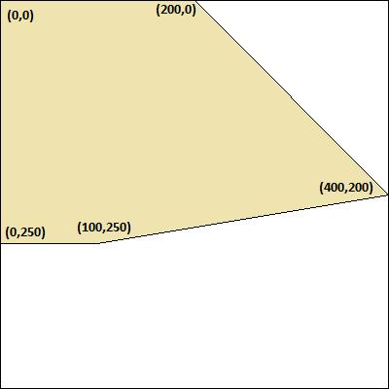
Figure. 1
Next he placed second glass piece as below figure:
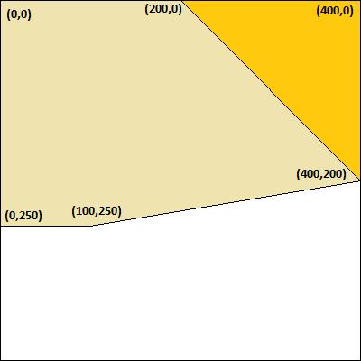
Figure. 2
Next he placed third glass piece as below figure:
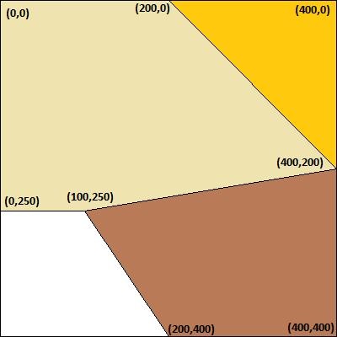
Figure. 3
Finally he found the position of the missing piece as below figure:
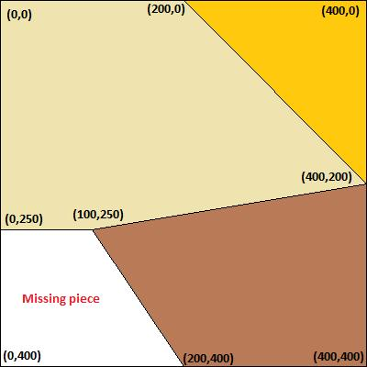
Figure. 4
Lastly, display the coordinates of missing glass piece in the clockwise direction starting from the corner (0,250), as output.

Home Lighting
Solution will be Updated soon…

Problem Description
You are moving to a new apartment and want to plan your total lighting cost for the next 2 years which includes the cost of bulb procurement and cost of electricity consumption. Three types of bulbs are available in the market.
1. Regular bulbs, which cost C1, have a warranty of M1 hours, and have a running cost of R1 per hour
2. CFL bulbs, which cost C2, warranty M2 hours, running, cost R2 per hour
3. LED bulbs, which cost C3, warranty M3 hours, running cost R3 per hour
C1 < C2 < C3 and R1 > R2 > R3, nothing can be said about M1, M2, and M3.
You have a plan for 1 bulb in the kitchen at H1 hours per day, 2 bulbs per room across 3 rooms at H2, H3, H4 hours per day per room per bulb, 1 bulb for bathroom at H5 hours per day.
When you prepare your budget you assume that it will last only till the warranty period.
Given the above requirements, come up with a bulb procurement plan that incurs least cost over 2 years – where cost includes procurement and running cost. In case warranty expires, in your model assume that the bulb will need to be replaced. Also assume that you will move out after 2 years, and so you are not concerned about stretching the life of bulbs beyond that time. Assume that there are 365 days in each year.

Constraints
C1 < C2 < C3
R1 > R2 > R3
0<= Fixed Cost <=1000
0<= Warranty<=150
0<= Running cost <=30000
0<= H1,H2,H3,H4,H5<=24

Input Format
The first three lines contains three integers denoting Fixed cost, Warranty and running cost of regular bulb, CFL and LED respectively.
The next five lines contain one integer each denoting usage hours of rooms (H1, H2, H3, H4, H5)

Output
Minimum cost to light the house.

Test Case

Explanation
Example 1
Input
50 1500 16
100 8000 14
400 25000 1
1
2
8
14
2
Output
38500
Explanation
Minimum cost for meeting all the lighting requirement of house is 38500.
Example 2
Input
50 10000 16
100 8000 14
800 25000 1
2
6
10
8
1
Output
41960
Explanation
Minimum cost for meeting all the lighting requirement of house is 41960.

